Panmure District School News

No.8 - Term.1, Week 8 – Monday 20 March 2017

Greetings, Kia ora, Talofa lava, Kia orana, Malo e lelei, Fakalofa Lahi Atu, Namaste, An Young Haseyo, Konichiwha, Bula Vinaka, Sawadee, Dobra Dan, Ni Hao, As-salamu alaykum, Hola

Visit to Ruapotoka Marae
Ruapotaka Marae Trip – Report by Junior Syndicate
On Monday 13th March, Rooms 6, 9 and 10 had a wonderful trip to Ruapotaka marae in Glen Innes. On arrival at 9.15am we were welcomed onto the marae with a pōwhiri.

Students learned the protocol of the Marae, history of the Marae, Mt. Maungarei, Panmure Basin and Panmure District School’s connection to the Marae.

Students also learned other cultural practices on the Marae like Karakia, action songs, haka and observing the making of a cloak (korowai). Student were given the opportunity to put a plastic house on the korowai. Korowai will be displayed at the Arts Exhibition. Our many thanks to the parents who came along to support us.
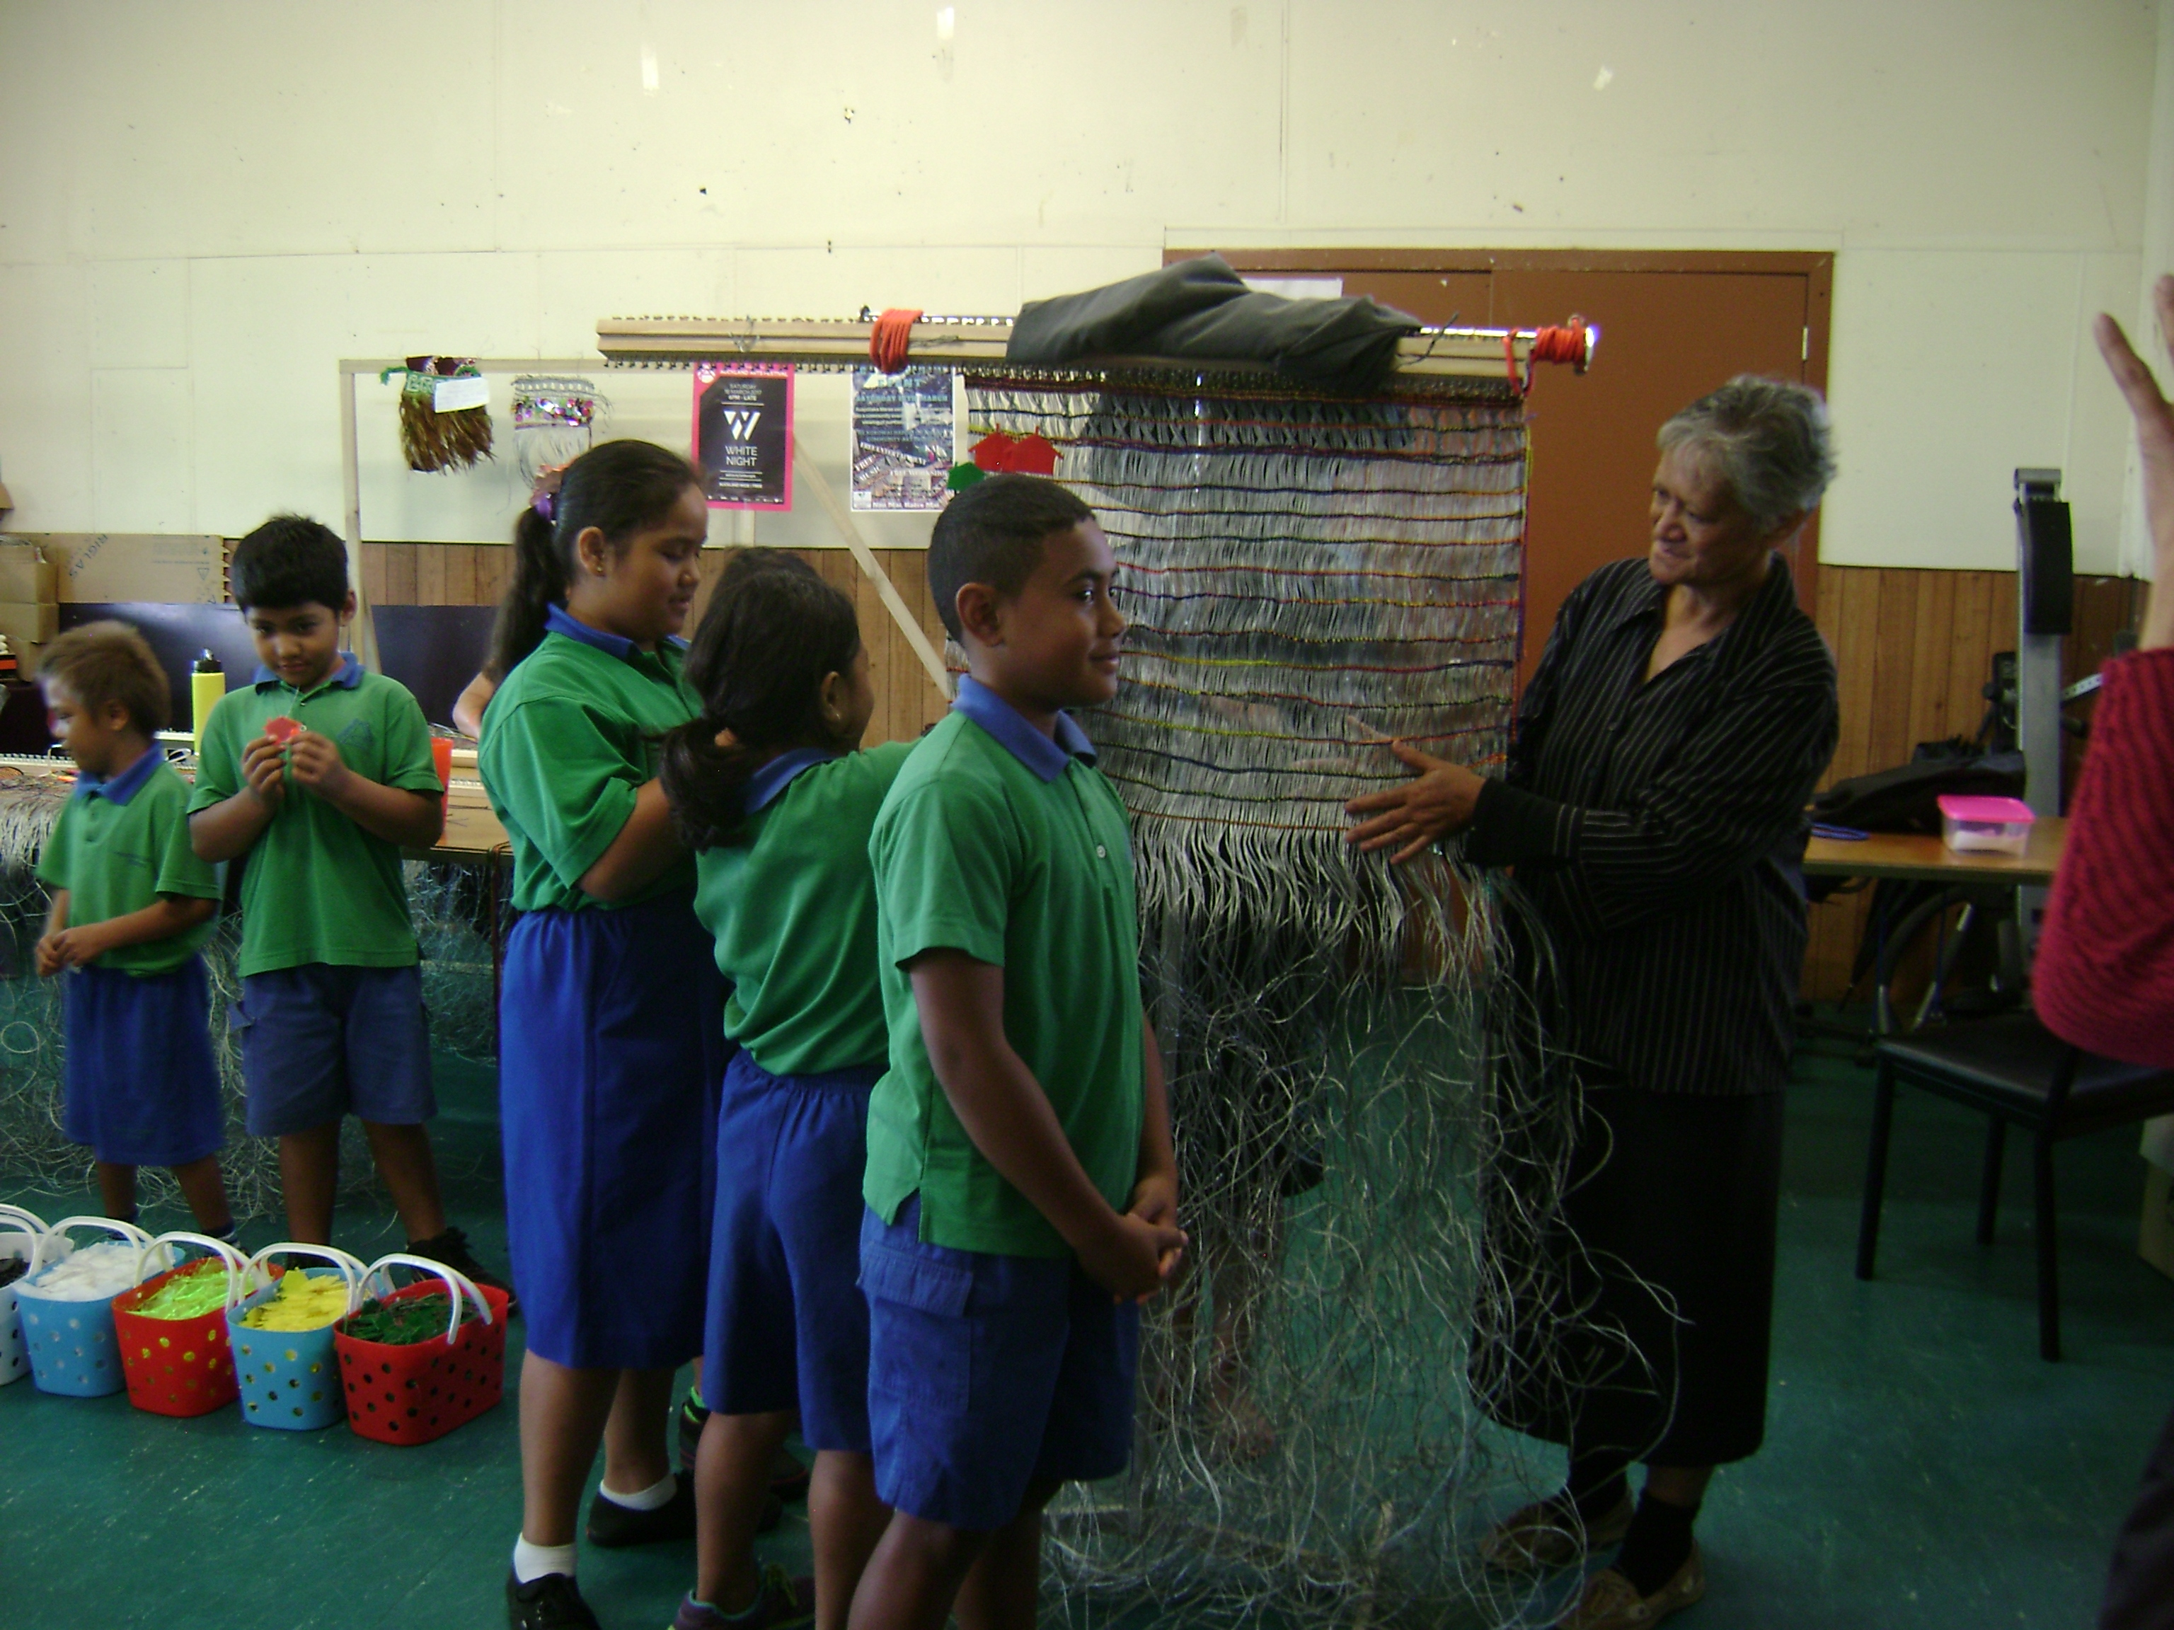

Visit to “Ruapotaka Marae” report by Senior Syndicate
As part of our inquiry learning on ‘Maori Cultural Practices’ we were keen to learn about local iwi history and experience Maori culture in a genuine setting. The Year 6, 7 and 8 students from Room 3 and 5 had the privilege to visit Ruapotaka Marae which is located in Glen Innes on Monday 13th March. We were transported to the Marae by bus and were escorted by Mrs.Ramkumar and Mr.Kumar. The weather was perfect, pleasant and sunny and it stayed bright and beautiful throughout the day.

As soon as we arrived, we were welcomed in a traditional manner. We learnt and experienced the protocol that they follow when the Powhiri or welcoming ceremony is done. During our visit we had learnt about the connection between our school and the Ruapotaka Marae and its people (tangata whenua), their beliefs, myths and legends, culture, language and we were also taught a waiata which we thoroughly enjoyed. At the end of the day the visit was a great experience getting involved with Maori culture where it had helped us a lot in our inquiry learning. The students were excited to share their experiences to their friends and family. To conclude we learnt quite a bit about the Tikanga and Te Reo Maori.

Student Led Conference
The student led conference was a great success as the parents had an awesome opportunity to discuss and understand classroom learning. Students were able to explain to their parents what they learn everyday in their own terms.

Hui / Fono Community Consultation Evening
Panmure District School invites you to our first hui/fono for 2017. Parents of ALL students are welcome to attend. The main topics we will be discussing are:
- Achievement data from the beginning of 2017
- The specific cultural values and principles you would like us to integrate into our classroom teaching
- What skills, knowledge, values and attitudes you would like your child to leave our school with at the end of Year 8
- Getting more family involvement in school, especially with the families of those students who require extra support
- Homework and tutoring sessions for you and your children
- Absences and lateness of students
- What you think is going well at our school and improvements you would like to see
All feedback from this meeting will be taken into consideration for our 2018 Action Plan.

This meeting is planned for as follows:
Date: Thursday 30th March
Time: 6 - 8pm
Venue: School Staffroom

Childcare:
There will be a social and movie evening for your children to attend during this time. If you have younger children they are also welcome to attend our movie evening.

This meeting will conclude with a light supper.

Fundraising for Performing Arts
Your Year 5 - 8 child has been invited to attend the School Social and your Year 1 – 4 has been invited to attend a Movie Evening, supporting the end of term 3 performing arts cultural festival. Drink and food will be provided.

Date: Thursday 30th March
Time: 6.00 pm – 8pm
Cost: $5.00

All children must be dropped off and collected from the hall by a parent/caregiver/or person that has been appointed by a parent or caregiver, at 8pm sharp. Students will not be able to leave the hall unless they are accompanied by an adult.

Tickets will be on sale from the classroom teacher and the children can purchase the tickets up to Thursday 30th March. The permission slip provided must be filled in and returned to purchase a ticket. No physical tickets will be handed out, students’ names will be on a list at the door if they have paid and returned their permission slip.

Merit Awards –
Room 3 –
Patilda Tuafafo for her passion for singing, dancing and assisting in class.

Juan Lizasoain Ren for using ICT skills to publish “ALL About Me”.

Room 4 -
Josiah Baker for sharing his ideas and understanding of the text read.

Krishan Patel for progress in oral reading and writing simple sentences.

Room 5 -
Hayley Pawhau for gaining confidence to participate and contribute her ideas during group discussions.

Benja Wanmontree for gaining confidence to express his thoughts and ideas clearly both verbally and through writing.

Room 6 –
Kartik Patel for being an active participant in small group discussions.

Lohitha Karanam for arriving at school everyday with a smile ready to learn.

Room 9 -
Manatu Tupou for listening during discussions.

Gamza Dakum for using good strategies to learn new words.

Room 10 -
Kaliveti Kaetau for modelling the meaning for 2 digit numbers.

Nature Hooper for always taking the initiative to share classroom responsibilities.

Environmental Award –
Room 05 – for the hardworking fruit and milk monitors.

Duffy Book Awards
Room 3 -
Makayla Harrison for making use of prior knowledge to understand text.

Melro Ares for trying to make inferences during reading.

Room 4 –
Sione Taulanga for expressing his understanding of the text and sharing with the class.

Toapasi Toki for his progress in reading comprehension and inferencing.

Room 5 -
Razel Padayo for asking and responding to questions during reading sessions.

Prinay Patel for reading and seeking additional information from his research work.

Room 6 –
Cloyan Ares for working well and participating in small guided reading groups.

Isaac Lauti for responding appropriately to other’s comments during partner / turn talk time.

Room 9 –
Akuila Kaetau for reading with confidence and explaining his story’s meaning.

Room 10 -
Beckham Sok for recalling and retelling stories.

Karmah Hepana for listening and responding to stories.

